Given an integer, n, perform the following condional acons:

Task

In this challenge, we're geng started with condional statements.

Q2) Problem Statement:

true

Sample Output 2

27 77

Sample Input 2

false

Sample Output 1

25 53

Sample Input 1

Example: II 698 and 768 are given, program should print true as they both end with 8.

digit, otherwise print false.

Write a program to read two integer values and print true if both the numbers end with the same

Q1) Problem Statement:

Week:03-01

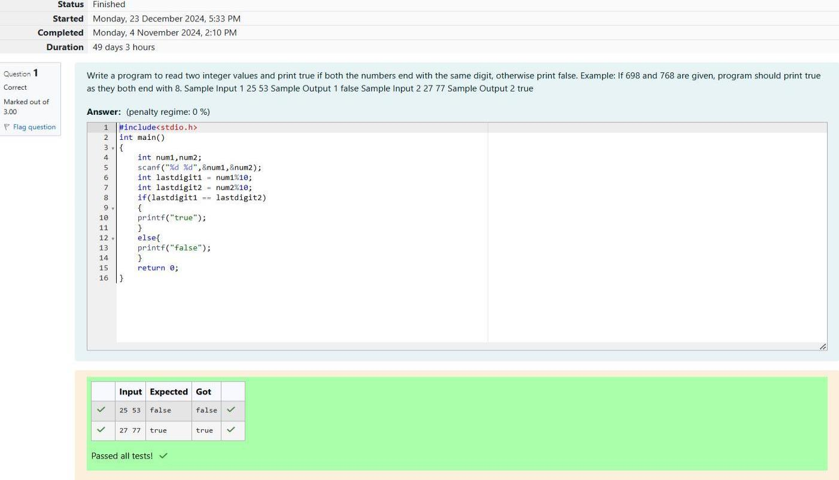

Weird

Sample Output 0

3

Sample Input 0

Print Weird if the number is weird; otherwise, print Not Weird.

Output Format

1<n<100

Constraints

A single line containing a posive integer, n.

Input Format

Complete the stub code provided in your editor to print whether or not n is weird.

If n is even and greater than 20, print Not Weird

If n is even and in the inclusive range of 6 to 20, print Weird

If n is even and in the inclusive range of 2 to 5, print Not Weird

If n is odd, print Weird

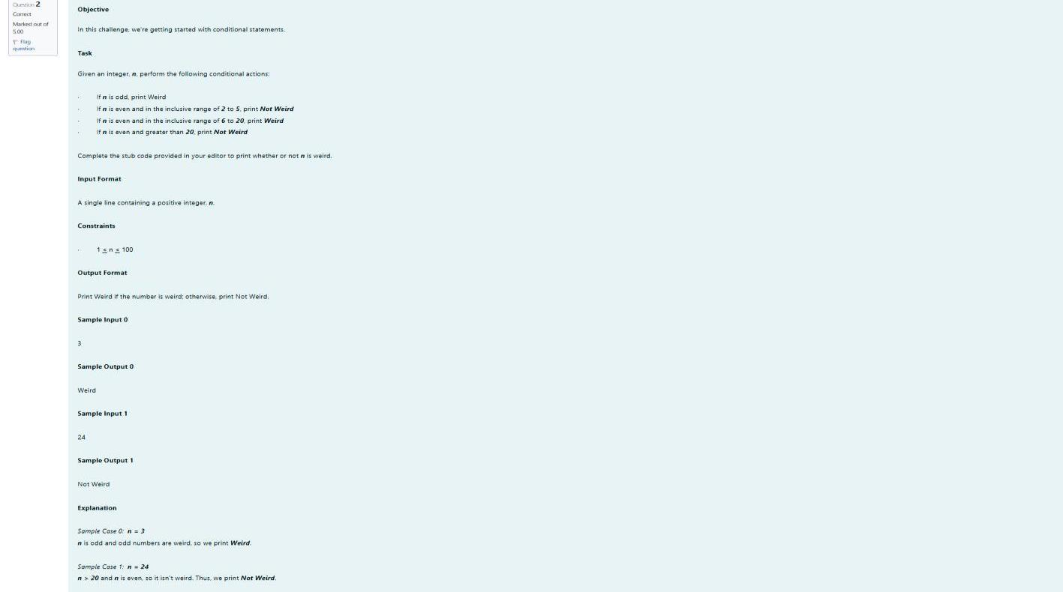

Yes

Sample Output 1

4

5

3

Sample Input 1

small leers.

Pythagorean triple, then print "yes", otherwise, print "no". Please note that the output message is in

You are given three integers, a, b, and e. They need not be given in increasing order. If they form a

For example, 3, 5 and 4 form a Pythagorean triple, since 3\*3+4\*4=25=6\*5

square of the third.

Three numbers form a Pythagorean triple if the sum of squares of two numbers is equal to the

Q3) Problem Statement:

OUTPUT:

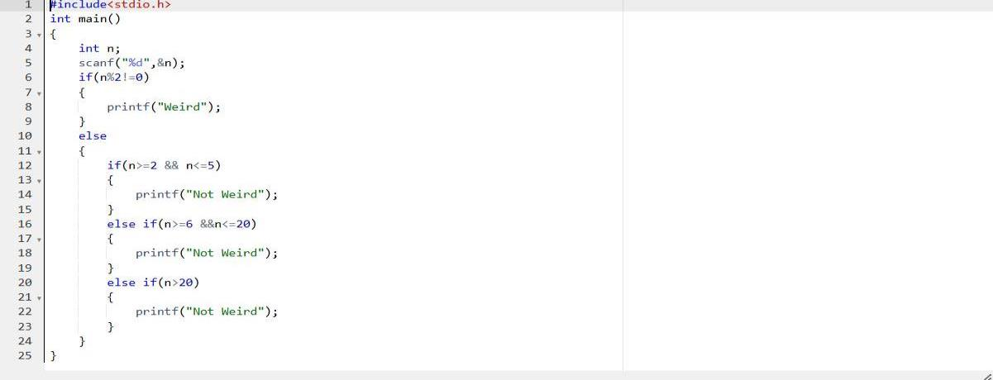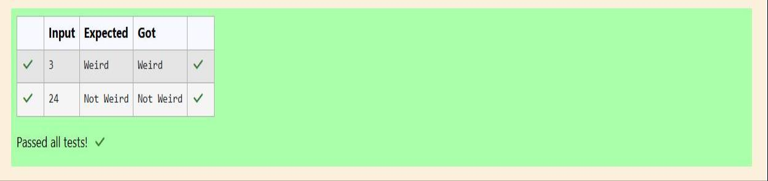

OUTPUT:

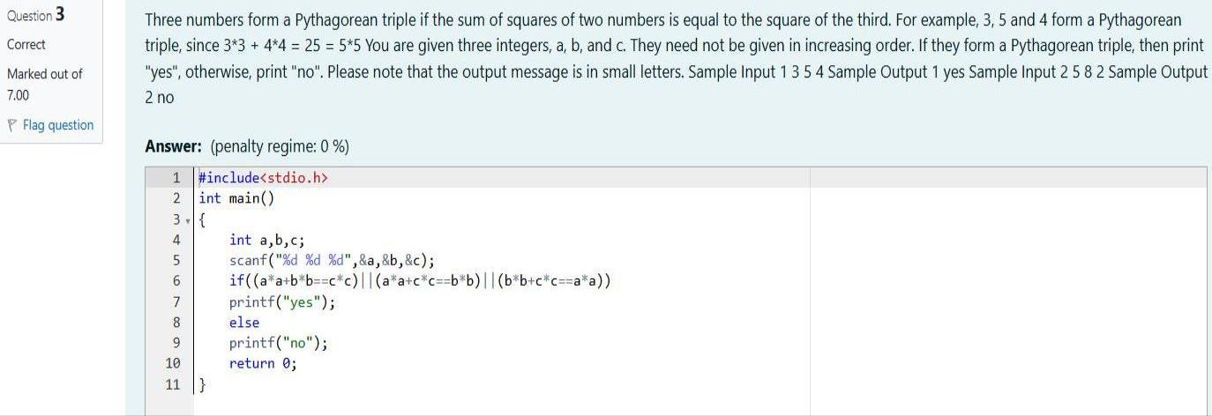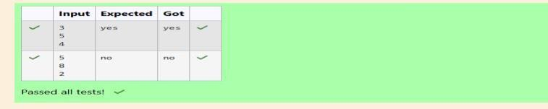

The number of sides is not supported.

Sample Output 3

11

Sample Input 3

Heptagon

Sample Output 2

7

Sample Input 2

Triangle

Sample Output 1

3

Sample Input 1

message.

sides outside of this range is entered then your program should display an appropriate error

program should support shapes with anywhere from 3 up to (and including) 10 sides. If a number of

sides from the user and then report the appropriate name as part of a meaningful message. Your

Write a program that determines the name of a shape from its number of sides. Read the number of

Q1) Problem Statement:

Week:03-02

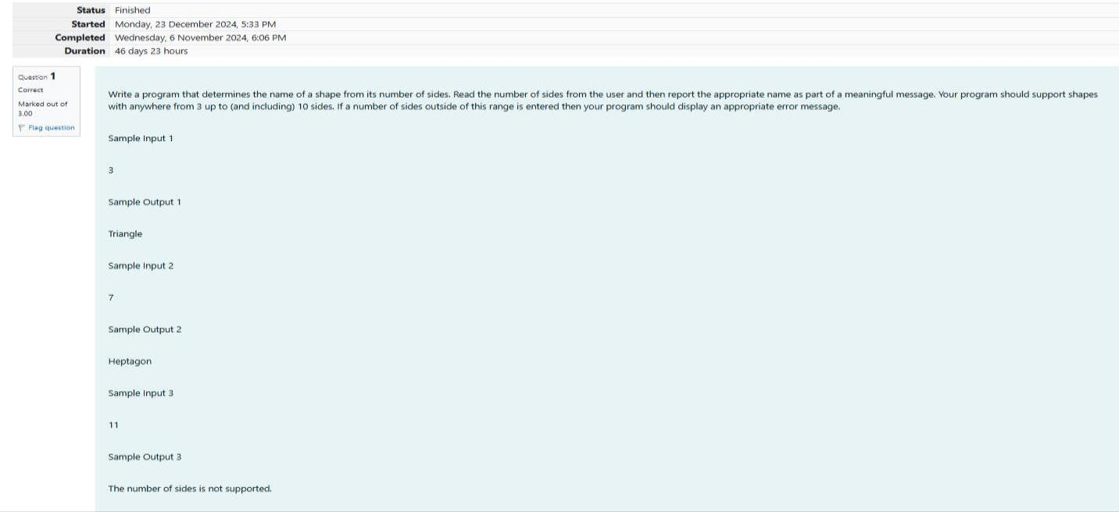

2009 Ox

2008 Rat

2007 Pig

2006 Dog

2005 Rooster

2004 Monkey

2003 Sheep

2002 Horne

2001 Snake

2000 Dragon

Year

Animal

being another year of the Hare.

table below. The paern repeats from there, with 2012 being another year of the Dragon, and 1999

The Chinese zodiac assigns animals to years in a 12-year cycle. One 12-year cycle is shown in the

Q2) Problem Statement:

OUTPUT:

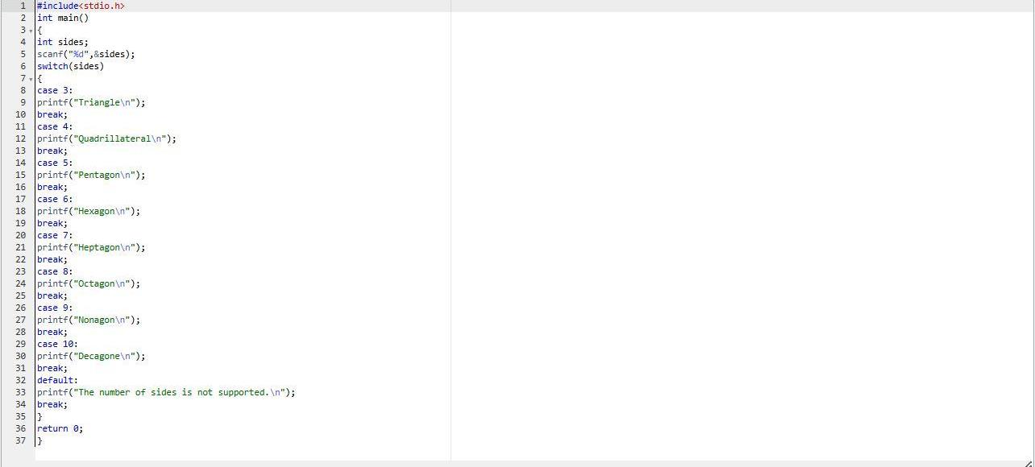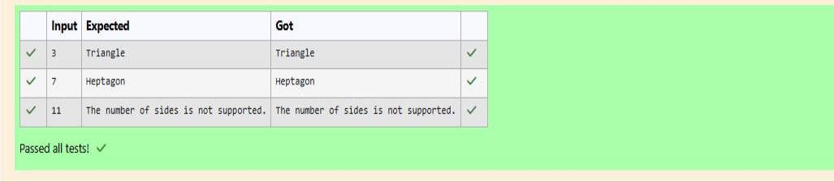

OUTPUT:

Tiger

Sample Output 2

2010

Sample Input 2

Monkey

Sample Output 1

2004

Sample Input 1

listed in the table.

Your program should work correctly for any year greater than or equal to zero, not just the ones

Write a program that reads a year from the user and displays the animal associated with that year.

2011 Hare

2010 Tiger

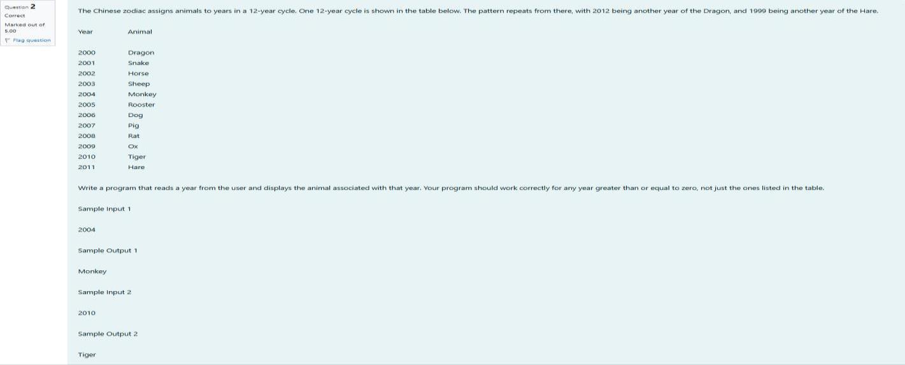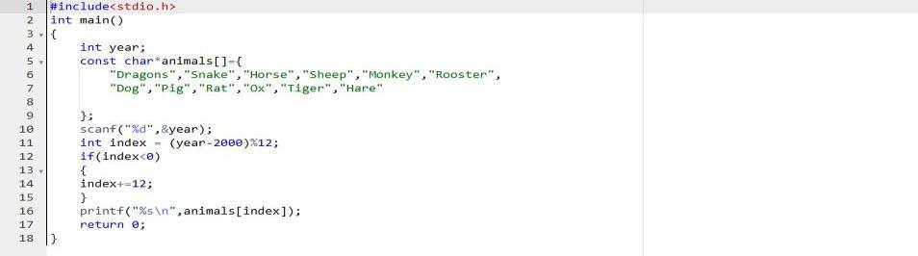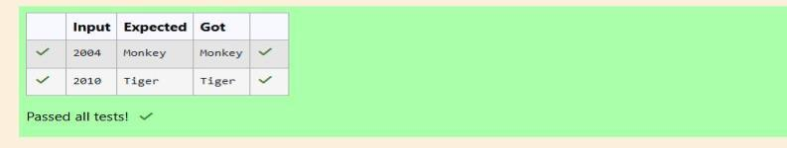

The square is white.

Sample Output 2

D 5

Sample Input 2

The square is black.

Sample Output 1

A 1

Sample Input 1

error checking.

program may assume that a valid posion will always be entered. It does not need to perform any

square is black. If the user enters d5 then your program should report that the square is white. Your

square in that row. For example, if the user enters al then your program should report that the

begins with a black square or a white square. Then use modular arithmec to report the color of the

Write a program that reads a posion from the user. Use an if statement to determine if the column

while the number idenes the row,

Posions on a chess board are idened by a leer and a number. The leer idenes the column,

Q3) Problem Statement:

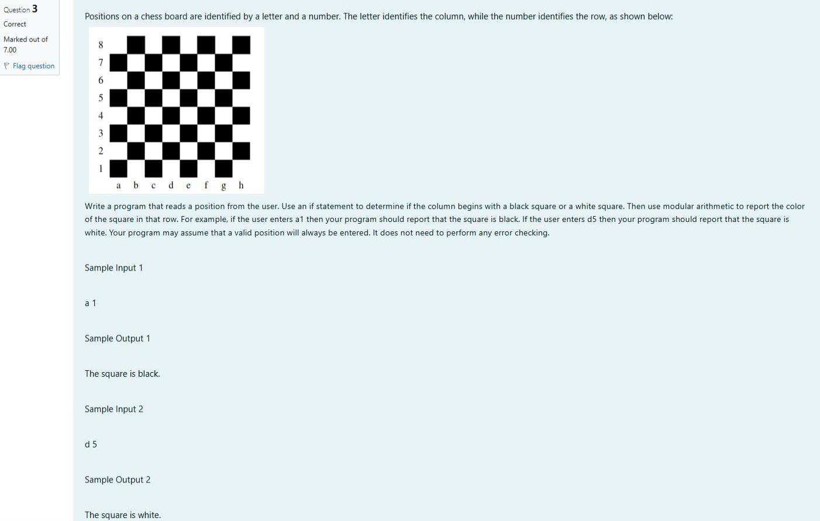

OUTPUT:

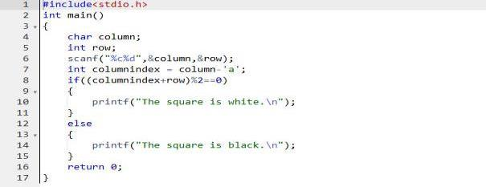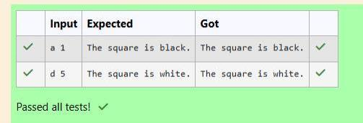

170

Sample Output 1

2020

6

18

Sample Input 1

Day of Year of a given date, month and year

Reverse the process to nd the standard date for a given day of year. Write a program to print the

month, then scan across to the appropriate month column and read the day of year number.

To nd the day of year number for a standard date, scan down the Jan column to nd the day of

400. So, 2000 was a leap year.

Leap years are divisible by 4. Centuries, Cent like 1900, are not leap years unless they are divisible by

There are two calendars - one for normal years with 365 days, and one for leap years with 366 days.

month. The day of year (DOY) is the sequenal day number starng with day 1 on January 1st.

Some data sets specify dates using the year and day of year rather than the year, month, and day of

Q1) Problem Statement:

Week:03-03

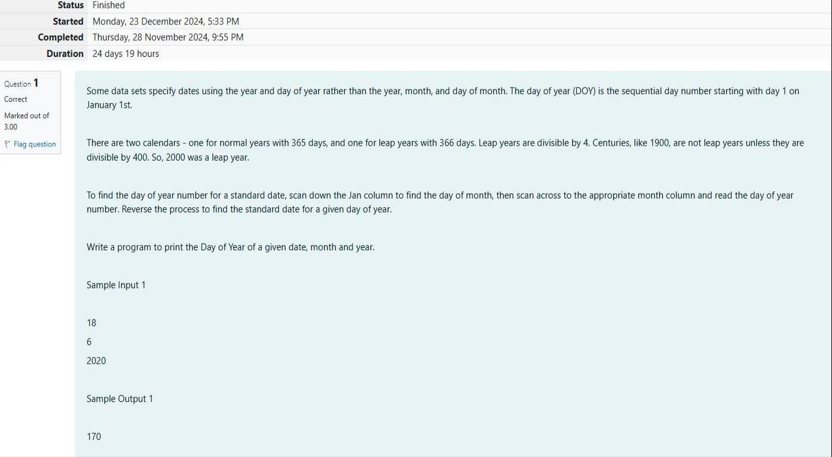

• Print the area of the shape.

Output Format

Note: In case of triangle, you can consider the sides as height and length of base

• Length of other side

• Length of 1 side

• Name of shape (always in upper case R -> Rectangle, S--> Square, T->Triangle)

Input Format

• Help Suppandi by prinng the correct answer in an integer.

say 0.

• And when he is confused, he just says something random. At this point, all you can do is

• When he says triangle, he is referring to a rectangle

• When he says square, he is actually referring to a triangle.

• When he says rectangle, he is actually referring to a square.

remembering the names of shapes. Instead, you will I be helping him calculate the area of shapes.

shapes and areas. Suppandi, is confused, he was never any good at math. And also, he is bad at

Suppandi is trying to take pan in the local village math qua. In the rst round, he is asked about

Q2) Problem Statement:

OUTPUT:

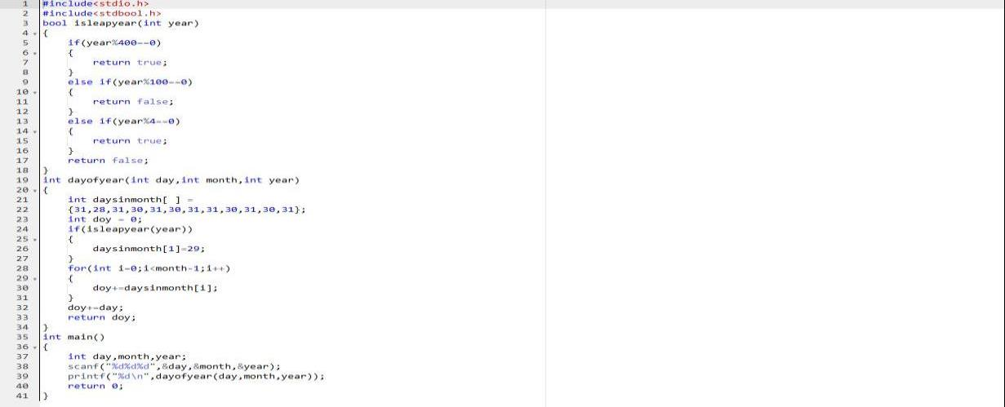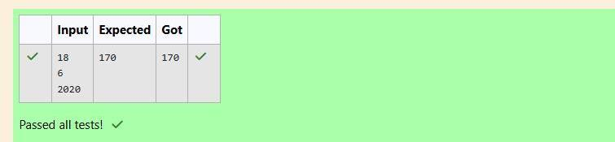

200

Sample Output 1

20

10

T

Sample Input 1

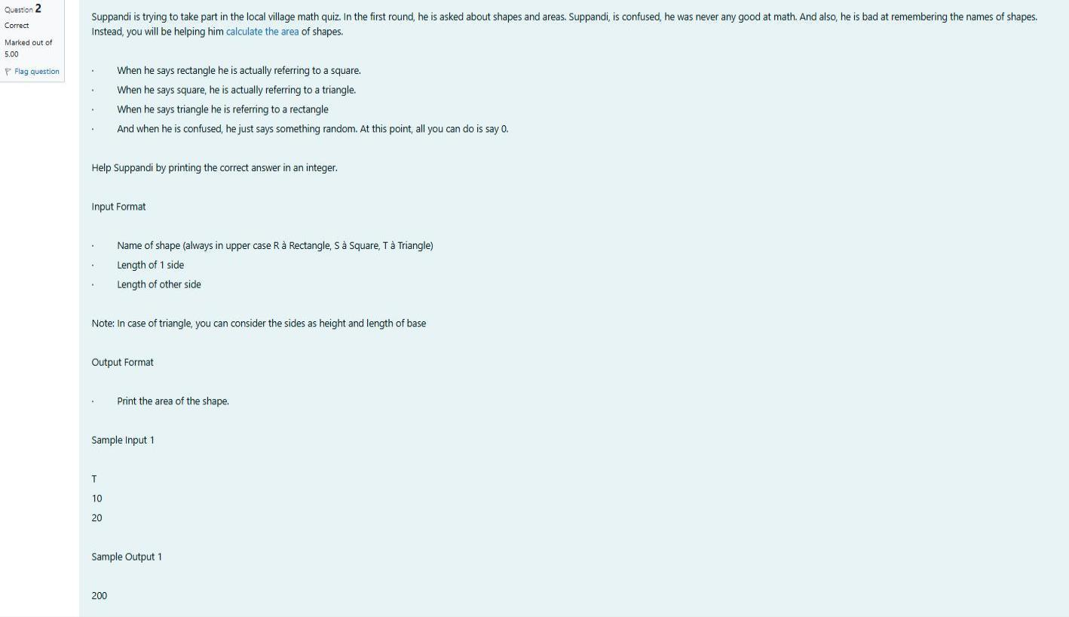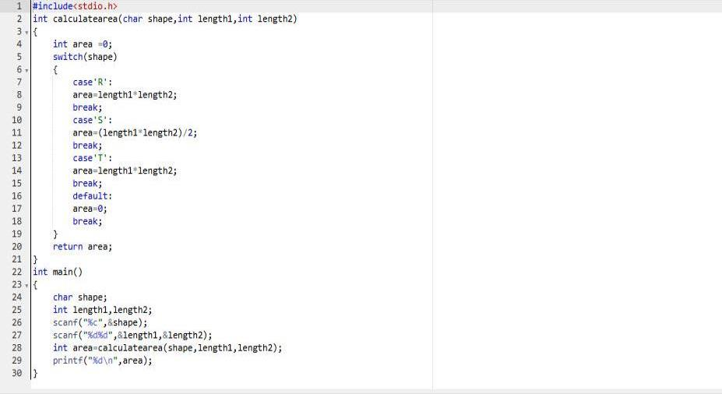

Output format:

Contain a number n (0 <n)

Input format:

arrive when you reach there.

You begin your journey on a Sunday and will reach after n. You have to tell on which day you will

• It has only 296 days. After the 296th day, it goes back to Sunday.

• The calendar starts with Sunday always.

Here are the rules of the calendar:

10

daxamday

9

coluday

8

kryptoday

7

Saturday

6

friday

5

thursday

4

wednesday

3

tuesday

2

monday

1

sunday

Day

Number Name of Day

week with the fou. They don't follow a 10-day following days: hitney follow

superday he arrives there. They to his home planet. It is very important for him to know which dy

Q3) Problem Statement:

OUTPUT:

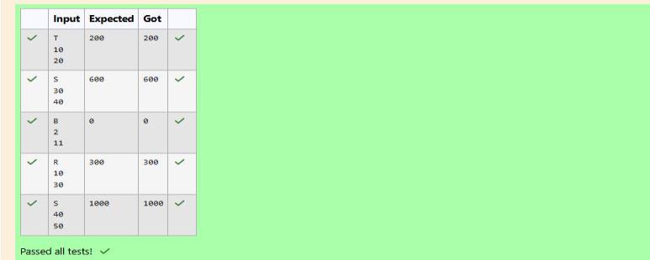

OUTPUT:

Monday

Sample Output

1

Sample Input

Kryptonday

Sample Output

7

Sample Input

Print the name of the day you are arriving on

